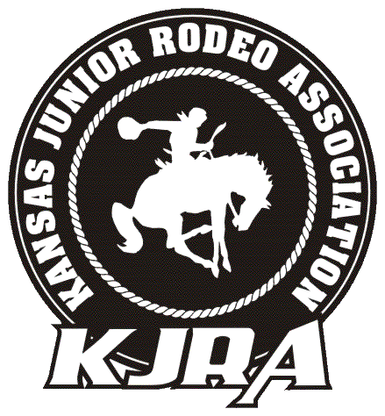
Kansas Junior Rodeo Association
— 2016 Membership Form —

Single Membership — $50 Family Membership — $80 Amount Paid:
Child 1:
Age as of 9/1/15: DOB: Gender: Grade: Shirt/Jacket Size:
Child 2:
Age as of 9/1/15: DOB: Gender: Grade: Shirt/Jacket Size:
Child 3:
Age as of 9/1/15: DOB: Gender: Grade: Shirt/Jacket Size:
Child 4:
Age as of 9/1/15: DOB: Gender: Grade: Shirt/Jacket Size:
Address: City: State: Zip:
Phone Number: Email Address:
A copy of contestants Birth Certificate must be on file with the Membership Secretary before the finals rodeo.
As a consideration for being allowed to attend and/or compete in the KJRA events, I the undersigned agree to the following:
Acknowledgement of Risk: The undersigned acknowledges that the KJRA events are dangerous activities and that the participation in said events, as either a contestant, and employee, or volunteer, exposes the participant to a substantial and serious risk of property damage, personal injury, or death. The undersigned expressly acknowledges that his/her participation will involve such hazards.
Release of Sponsors: RELEASE, DISCHARGE, AND COVENANT NOT TO SUE the rodeo committee, stock contractor, rodeo association, sponsors, arena operators or owners, and each of them, their officers, agents and employees (all hereafter collectively referred to as “Releasee”) from any and all claims and liability arising out of strict liability or ordinary negligence of Releasee, or any other participant which causes the undersigned injury, death, damages, or property damage. We, the undersigned, jointly and in common, covenant to hold Releasee harmless and to indemnity releasee from any claim, judgment or expenses releasee may incur arising out of any of this minor’s activities or presence in the restricted area.
Assurances: The undersigned has full power, authority, capacity, and right without limitation to execute, deliver, and perform this release.
Rules: The undersigned agrees to abide by all rules governing KJRA.
Binding Effect: This release shall be binding upon the undersigned and the undersigned’s spouse, legal representatives, heirs, successors, and assigns.
Note: All participants must have the following notarized by their parent or guardian regardless of age.
Consent to Treat: I hereby give the local EMS or local hospital the right to treat the above listed child/children, which I am the parent or guardian of, should the need arise.

I have read the above release in full. I totally understand its terms and conditions, and I hereby voluntarily execute and deliver this consent to contestant’s attendance/participation in any/all KJRA events. I further agree to be fully bound by the terms and conditions of the release in both an individual capacity and in my capacity as parent or legal guardian for the undersigned.

Parent/Guardian Signature: Date:
Parent/Guardian Printed Name:

KJRA MEMBERSHIP REQUIREMENTS

There are a few requirements that must be met before your child will be eligible for Finals and awards. These requirements are:
- Participate in each event that you elect to enter at Finals a minimum of 6 times throughout the season.
- Turn in a minimum of $200 worth of sponsorship and/or raffle tickets per child by the required date (to be determined).
- Parents will be assigned events to work at each rodeo that their child/children are entered. Work schedules will be emailed to families with the weekend day sheets. Workers are to report to the event directors prior to the event they are working. The event director shall report to the rodeo secretary anyone who does not show up to work their scheduled event. Failure to work an event will result in a $25 penalty that will be required to be paid prior to a contestant entering the next rodeo. Anyone with outstanding penalties will not be eligible for Finals or year-end awards.
- You are encouraged but not required to bring at least one (1) item per child to our auction that we hold every year at the Finals. All this money goes towards the kids’ prize fund, so the nicer auction we have, the better the awards.

